SECTION EUROPEENNE
Epreuve spécifique de sciences physiques en anglais.

WiFi Radiation - Is WiFi Technology Bad For Your Health?

The technological benefits of Wireless Fidelity technology versus the wireless hazards is a hot debate in many different countries. In the United States, a class action lawsuit has been brought against a school board who uses the technology in their classrooms. In Britain, it has been removed from some classrooms.
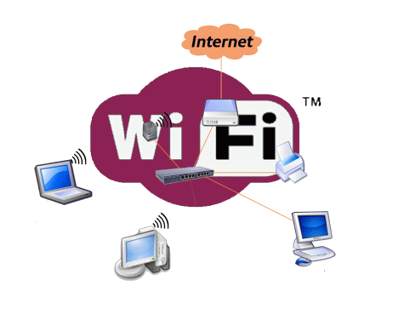 | WiFi is the wireless technology most commonly used to connect people to the internet at home, in schools, hotels...  A wireless network uses radio waves at a frequency level of 2.4 GHz similar to micro waves and send communications across a two-way network : from the wireless router to your laptop and in the reverse way.  Wi-Fi is certainly convenient, but is it dangerous? Many believe that the low-level electromagnetic waves that radiate from the wireless internet source to each individual user can be harmful to your health, even causing cellular changes and possibly cancer.
Officially, the levels of WiFi electromagnetic radiation emitted into the environment in a hotspot * are well below recommended levels and there is no evidence of any risk to humans.
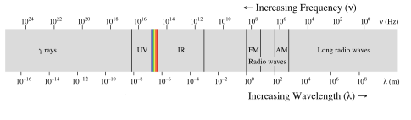
Dr. Michael Clark of the HPA (a UK health agency similar to the American CDC**) said, “When we have conducted measurements in schools, typical exposures from Wi-Fi are around 20 millionths of the international guideline levels of exposure to radiation. As a comparison, a child on a mobile phone receives up to 50 percent of guideline levels. So, a year sitting in a classroom near a wireless network is roughly equivalent to 20 minutes on a mobile. If Wi-Fi should be taken out of schools, then the mobile phone network should be shut down, too — and FM radio and TV, as the strength of their signals is similar to that from Wi-Fi in classrooms.”
*(The area covered by a Wi-Fi internet connection is called a hotspot)
** CDC : center for disease control and prevention
TASK : use the text to explain how a Wifi works, and the danger you could incur by using it. You can use the guideline below to organize your presentation but feel free to use them in any order you like.
- A micro wave is an electromagnetic wave; explain what it means and the difference with a mechanical wave.
- Use the documents to explain the feature of a wave.
- Explain how the micro waves can be used in a micro wave oven to increase the temperature of the food.
- Some scientists investigate the potential dangers of an exposure to some electromagnetic waves. Have you ever heard about it?

