SECTION EUROPEENNE
Epreuve spécifique de sciences physiques en anglais

How Radar Guns and Radar Detectors Work

The basic idea behind radar is very simple: a signal is transmitted, it bounces off an object and it is later received by some type of receiver. This is like the type of thing that happens when sound echo's off a wall. However radars don't use sound as a signal. Instead they use certain kinds of electromagnetic waves called radio waves and microwaves. This is where the name RADAR comes from (RAdio Detection And Ranging). Another type of signal used that is relatively new is laser light that is used in devices called LIDAR (LIght Detection And Ranging).
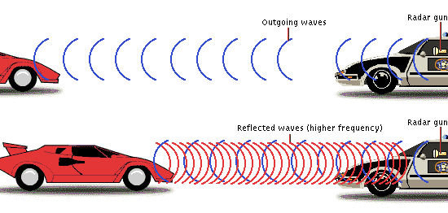

Radio waves and microwaves are two types of electromagnetic waves. Electromagnetic waves, which we will call EM waves, like all waves transport energy but can, do so through a vacuum. Sound waves and ocean waves require matter to transport energy but EM waves can do so without the presence of matter. Because of this, satellites can use radars to work on projects outside of the Earth's atmosphere and on other planets. Another useful thing about EM waves is that they travel at a constant speed through a vacuum called the speed of light abbreviated by the letter "c" (299,792,458 meters per second).

TASK : You are in a car with your young brother and you see a police car doing a speed check. Explain how RADAR works.
You can use the following guidelines below to organize or support your presentation; feel free to use them in any order you like.
  - Describe how RADAR detects a car’s speed.
  - Explain why we use EM waves in space.
  - Give examples of other uses of radiowaves and microwaves

