SECTION EUROPÉENNE

Épreuve spécifique de Sciences Physiques en anglais

Using a microwave oven and cheese on toast to measure the speed of light .

DOCUMENT 1:
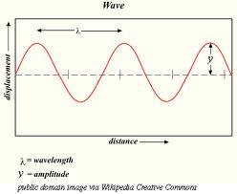

DOCUMENT 2 : video“cheese on toast and speed of light.mpg”. ( 2:43)

TASK: You are one of the students in the audience. Back in the classroom, you’ll have to explain the experiment you have seen, using any knowledge you have on this topic.

You can use the topics below to organise and support your presentation, but feel free to use them in any order you like.

- What is a wave?
- What are the characteristics of waves?
- A micro wave is an electromagnetic wave: explain what this means and the difference with a mechanical wave.

