SECTION EUROPEENNE
Epreuve spécifique de sciences physiques en anglais.
Momentum
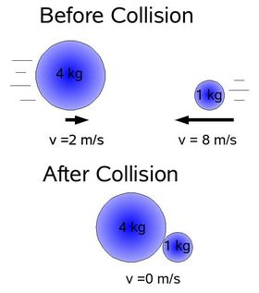
Document 1 :

Document 2 : video « momentum in space »

Document 3 :
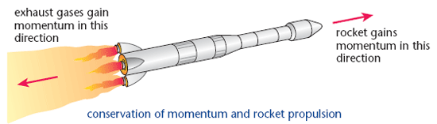

TASK: Explain what you know of momentum and its applications.
You can use the topics below to organise and support your presentation, but feel free to use them in any order you like.
- What is momentum ?
- Explain the experiment on the video.
- How can the conservation of momentum explain the motion of a rocket ?

