SECTION EUROPEENNE
Epreuve spécifique de Sciences physiques en anglais.
Free fall from space
The purpose of the “RedBullStratos” mission is to transcend human limits. Supported by a team of experts Felix Baumgartner ascended to 128,100 feet (39,045 km) in a stratospheric balloon and made a free fall jump rushing toward earth at supersonic speeds before parachuting to the ground. His successful feat on Oct. 14, 2012 holds the potential to provide valuable medical and scientific research data for future pioneers.

Doc1: Mission steps (as they were scheduled)
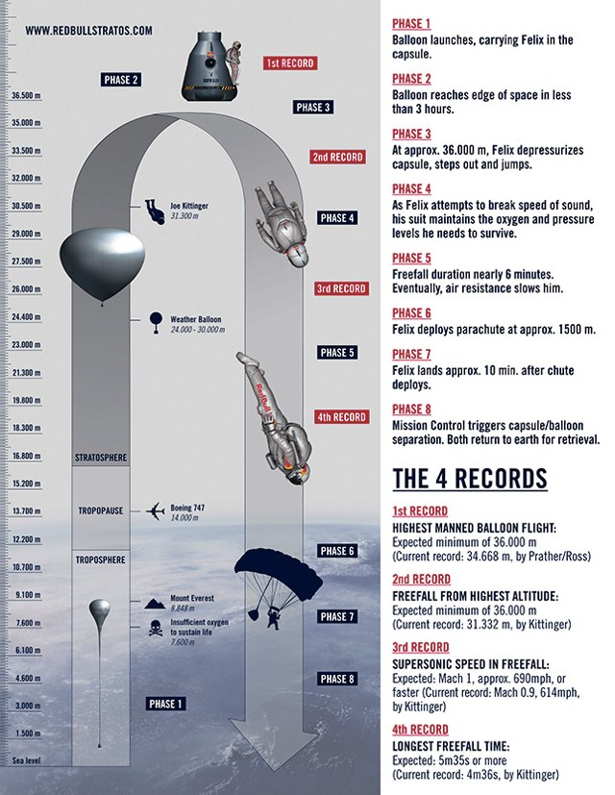

Doc 2: Speed of sound and speed of Felix Baumgartner vs. time (closed parachute)  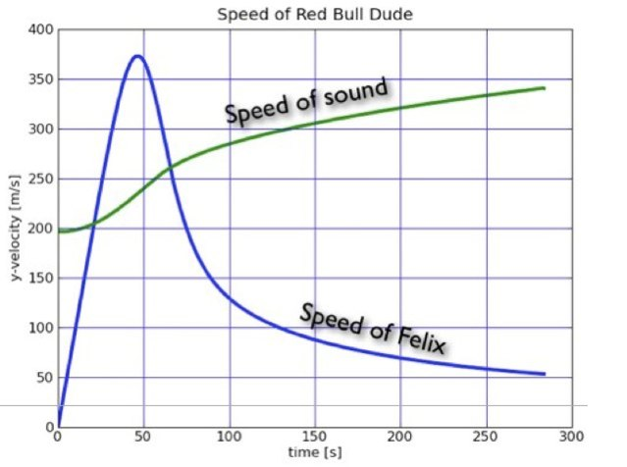 |   Doc 3: Speed of a classical skydiver vs. time 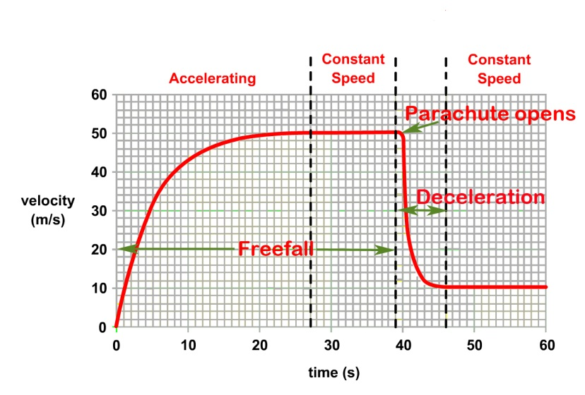
Doc 4: Earth’s Atmosphere pressure:  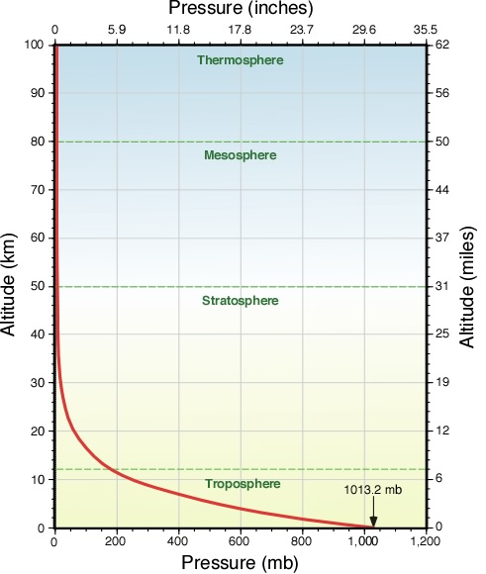  (millibars) | Doc 5: Freefalling object (No air friction)  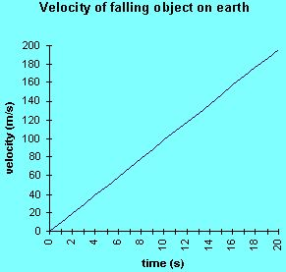

TASK : You are a science expert in a TV program. You have to explain Felix motion during his fall.

You can use the documents, your knowledge and the guidelines below to organise and support your presentation, but feel free to use them in any order you like.

- State the Newton’s laws
- What forces are exerted on Felix during the fall?
- Explain the differences with a classical skydiver’s fall

