SECTION EUROPEENNE
Épreuve spécifique de Sciences Physiques en anglais
REACTION RATES
DOCUMENTS

Document 1: Watch the Video: Reaction_Rates_clip.mp4

Document 2:

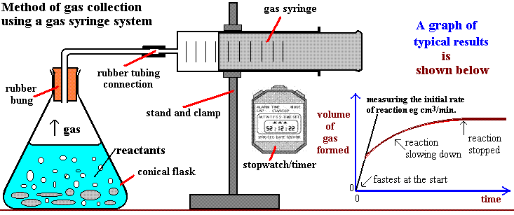

Equation : Mg_{(s)} + 2H⁺_{(aq)} Mg²⁺_{(aq)} + H_{2(g)}

Task: Use the documents above to describe the kinetic factors affecting the rate of a reaction.
You can use the guidelines below to organize or support your presentation, but feel free to use them in any order you like.
- What are the kinetic factors described in the video? Do you know of any other factors?
- You have to investigate the influence of one kinetic factor on the rate of the reaction between hydrochloric acid and zinc. Explain how you would perform the experiment and the results you would obtain.
- Why is it important to be able to control the rate of a reaction?

