SECTION EUROPEENNE  
Epreuve spécifique de sciences physiques en anglais

**COLD CHAIN**

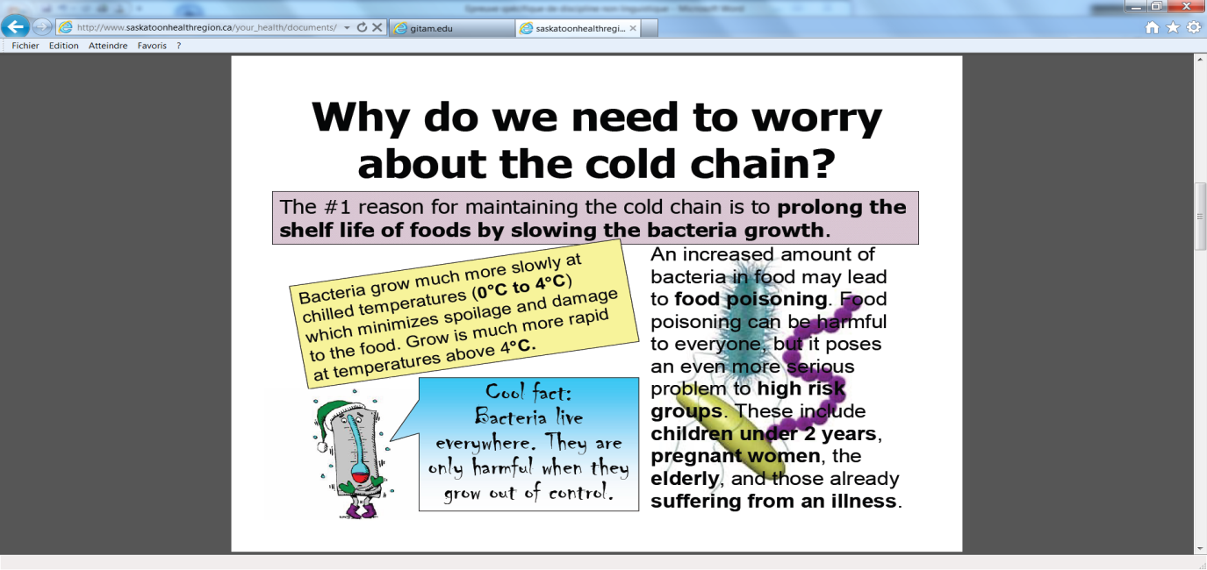

*Explanatory leaflet for foodworkers*

|  |
| --- |
| Temperature is the most important factor that determines the rates of growth, multiplication and survival of all living organisms, such as bacteria. Growth and reproduction of living organisms are dependent on a coordinated series of enzyme-catalysed chemical reactions. The rates of enzyme reaction increase with the increase in temperature.  *From GITAM microbiology laboratory* |

Simulation of behaviour of bacteria “E.coli” in chocolate cream at 10°C (dotted line) and 15 °C (solid line):



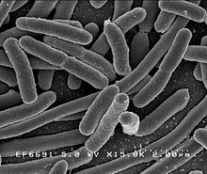

*Escherichia.coli. is a bacterium that can get into food and that can cause serious infections.*

**TASK:**

**You are a physician responsible for a food storing service in a hospital.**

**Use scientific argument to convince employees of the importance to store the food in a cold place and to maintain the cold chain.**

*You can use the documents and your knowledge to organise and support your presentation, feel free to use them in any order you like.*

Keywords you may use : kinetic factors, half-reaction time and collision theory.