SECTION EUROPÉENNE
Épreuve spécifique de sciences physiques en anglais

Why should we gradually replace all petrol cars by electric cars?
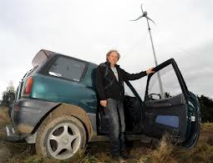
Electric car powered by a wind turbine

The main problem of an electric car is its autonomy when you have to travel long distances. How about having a break while the battery of your electric car is charged for 2 hours?
An electric vehicle does not necessarily emit low carbon: it could have nearly as large a footprint as a petrol car, depending on how the electricity is generated. Certain motorway petrol stations in England are offering a free charge using wind turbines and solar panels if you register on line at these stations.

The economic argument can be really interesting and using an electric car can really contribute to saving the environment.

Task : You are an expert in ecology and you will have to convince your Minister of the environment why it is interesting to gradually increase the number of electric cars in the country.

Use the document and any other knowledge, for your exposé.
The following questions are guidelines. Feel free to use them in any order you like.

- Discuss the necessity of reducing the emission of CO₂ for our planet.
- Is it possible to generalise the project?
- The electric car will not emit CO₂ if wind turbines are used to produce energy. Discuss.
- Discuss the future of electric cars.

