SECTION EUROPÉENNE
Épreuve spécifique de Sciences Physiques en anglais
Liming
DOCUMENT 1:
Extracted from “To Treat the Attack of Acid Rain, Add Limestone to Water and Wait
By WILLIAM K. STEVENS Published: January 31, 1989 (New York times)”
In a nascent counterattack on the effects of acid rain, American scientists and wildlife experts are increasingly bringing dead lakes and streams back to life by using the simple technique of adding limestone [CaCO₃] to the water.
The technique, long used in Sweden, is not a permanent solution to the problem of acidification, experts say. That will come only when the industrial emissions that cause acid rain are sufficiently reduced, even proponents of the treatment method say. But they believe that ''liming,'' as it is called, now offers a practical way to stave off some damage caused by acid rain until there is a permanent solution. It also restores the health of some lakes and streams where life has already been destroyed by acidification.
Nevertheless, large scale or small, the effects are reported to be dramatic. The alkaline character of the limestone rapidly offsets a lake's acidity, rapidly restoring the water to a neutral condition, or nearly so. From the smallest algae to the biggest fish in the food chain, the populations of acidic or acidifying lakes gradually re-establish themselves after liming, although restocking of fish speeds up the process.
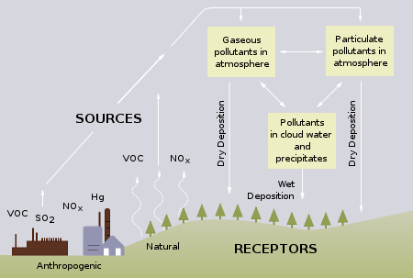
DOCUMENT 2: DOCUMENT 3:
Carbonate ions (CO₃²⁻) belong to the acid/base pair: HCO₃⁻/CO₃²⁻.

Task : You organize a meeting in a village located near a chemical factory. You have to explain to the population the reasons why the water is too acidic in the lakes and how to solve that problem using limestone.
You can use the topics below to organize your presentation but feel free to use them in any order you like.
- What are acids and alkalis?
- What are the sources of the acids in acid rain?
- What are the advantages and drawbacks of liming?

