SECTION EUROPÉENNE

Épreuve spécifique de Sciences Physiques en anglais

Bubble-gum

DOCUMENT 1:
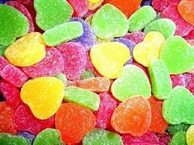
If your sweets make you foam at the mouth, or purse your lips and narrow your eyes, it’s probably due to some neat acid-base chemistry.
Those super-sour sweets contain a mixture of malic acid (found in apples) and citric acid (found in lemons, limes and oranges).
Foaming bubble-gums rely on these acids reacting with sodium hydrogen carbonate in the gum. The acids ionise in the moisture in your mouth, forming H₃O⁺_{(aq)} ions. The H₃O⁺_{(aq)} ions then react with hydrogen carbonate ions producing carbon dioxide gas, which makes the foam.

DOCUMENT 2:
The hydrogen carbonate ions belong to the acid/base pair: CO₂, H₂O/HCO₃⁻.

DOCUMENT 3: Video « Properties of acids and bases »

TASK:You want to explain to your mother that the foam forming in your mouth when you eat sweets isn’t toxic. Tell her what acids and bases are and what kind of reaction occurs.

You can use the topics below to organize and support your presentation, but feel free to use them in any order you like.

- According to Brönsted’s theory, what is an acid? What is a base?
- What happens when you mix an acid and a base?
- What are their properties? Give some safety rules when handling acids and bases.
- Define the pH scale and illustrate with some everyday life products.

